Project Life Cycle
A project life cycle is the series of phases that a project passes through from its initiation to its closure. The phases are generally sequential, and their names and numbers are determined by the management and control needs of the organization or organizations involved in the project, the nature of the project itself, and its area of application. The phases can be broken down by functional or partial objectives, intermediate results or deliverables, specific milestones within the overall scope of work, or financial availability. Phases are generally time bounded, with a start and ending or control point. A life cycle can be documented within a methodology. The project life cycle can be determined or shaped by the unique aspects of the organization, industry, or technology employed. While every project has a definite start and a definite end, the specific deliverables and activities that take place in between will vary widely with the project. The life cycle provides the basic framework for managing the project, regardless of the specific work involved.
Project life cycles can range along a continuum from predictive or plan-driven approaches at one end to adaptive or change-driven approaches at the other. In a predictive life cycle, the product and deliverables are defined at the beginning of the project and any changes to scope are carefully managed. In an adaptive life cycle, the product is developed over multiple iterations and detailed scope is defined for each iteration only as the iteration begins.
Characteristics of the Project Life Cycle
Projects vary in size and complexity. All projects can be mapped to the following generic life cycle structure
- Starting the project,
- Organizing and preparing,
- Carrying out the project work, and
- Closing the project.
This generic life cycle structure is often referred to when communicating with upper management or other entities less familiar with the details of the project. It should not be confused with the Project Management Process Groups, because the processes in a Process Group consist of activities that may be performed and recur within each phase of a project as well as for the project as a whole. The project life cycle is independent from the life cycle of the product produced by or modified by the project. However, the project should take the current life-cycle phase of the product into consideration. This high-level view can provide a common frame of reference for comparing projects—even if they are dissimilar in nature.
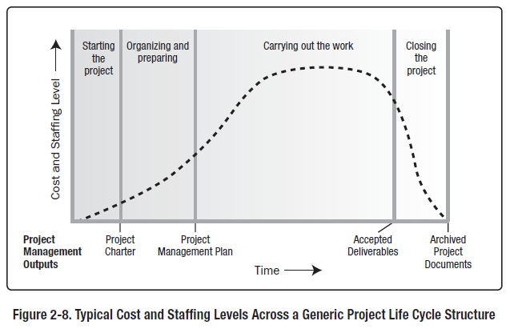
The generic life cycle structure generally displays the following characteristics:
- Cost and staffing levels are low at the start, peak as the work is carried out, and drop rapidly as the project draws to a close. Figure 2-8 illustrates this typical pattern.
- The typical cost and staffing curve above may not apply to all projects. A project may require significant expenditures to secure needed resources early in its life cycle, for instance, or be fully staffed from a point very early in its life cycle.
- Risk and uncertainty (as illustrated in Figure 2-9) are greatest at the start of the project. These factors decrease over the life of the project as decisions are reached and as deliverables are accepted.
- The ability to influence the final characteristics of the project’s product, without significantly impacting cost, is highest at the start of the project and decreases as the project progresses towards completion.
Figure 2-9 illustrates the idea that the cost of making changes and correcting errors typically increases substantially as the project approaches completion. While these characteristics remain present to some extent in almost all project life cycles, they are not always present to the same degree. Adaptive life cycles, in particular, are developed with the intent of keeping stakeholder influences higher and the costs of changes lower throughout the life cycle than in predictive life cycles.
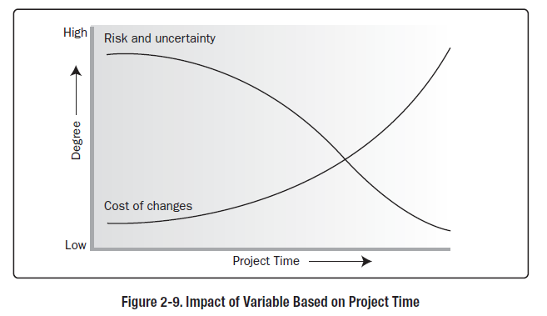
Within the context of the generic life cycle structure, a project manager may determine the need for more effective control over certain deliverables or that certain deliverables are required to be completed before the project scope can be completely defined. Large and complex projects in particular may require this additional level of control. In such instances, the work carried out to complete the project’s objective may benefit from being formally divided into phases.

Project Phases
A project may be divided into any number of phases. A project phase is a collection of logically related project activities that culminates in the completion of one or more deliverables. Project phases are used when the nature of the work to be performed is unique to a portion of the project, and are typically linked to the development of a specific major deliverable. A phase may emphasize processes from a particular Project Management Process Group, but it is likely that most or all processes will be executed in some form in each phase. Project phases typically are completed sequentially, but can overlap in some project situations. Different phases typically have a different duration or effort. The high-level nature of project phases makes them an element of the project life cycle. The phase structure allows the project to be segmented into logical subsets for ease of management, planning, and control. The number of phases, the need for phases, and the degree of control applied depend on the size, complexity, and potential impact of the project. Regardless of the number of phases comprising a project, all phases have similar characteristics:
- The work has a distinct focus that differs from any other phase. This often involves different organizations, locations, and skill sets.
- Achieving the primary deliverable or objective of the phase requires controls or processes unique to the phase or its activities.
- The closure of a phase ends with some form of transfer or hand-off of the work product produced as the phase deliverable. This phase end represents a natural point to reassess the activities underway and to change or terminate the project if necessary. This point may be referred to as a stage gate, milestone, phase review, phase gate or kill point. In many cases, the closure of a phase is required to be approved in some form before it can be considered closed.
There is no single ideal structure that will apply to all projects. Although industry common practices will often lead to the use of a preferred structure, projects in the same industry—or even in the same organization—may have significant variation. Some will have only one phase, as shown in Figure 2-10. Other projects may have two or more phases.
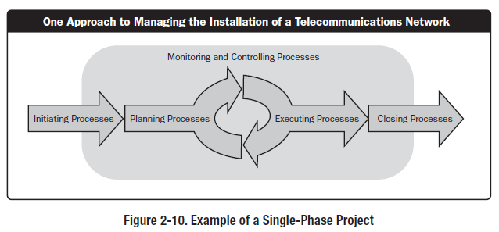
Phase-to-Phase Relationships
When projects have more than one phase, the phases are part of a generally sequential process designed to ensure proper control of the project and attain the desired product, service, or result. However, there are situations when a project might benefit from overlapping or concurrent phases.
Sequential relationship: In a sequential relationship, a phase starts only when the previous phase is complete. Figure 2-11 shows an example of a project with three entirely sequential phases. The step-by-step nature of this approach reduces uncertainty, but may eliminate options for reducing the overall schedule.
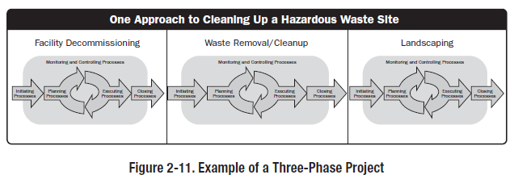
Overlapping relationship: In an overlapping relationship, a phase starts prior to completion of the previous one (see Figure 2-12). This can sometimes be applied as an example of the schedule compression technique called fast tracking. Overlapping phases may require additional resources to allow work to be done in parallel, may increase risk, and can result in rework if a subsequent phase progresses before accurate information is available from the previous phase.
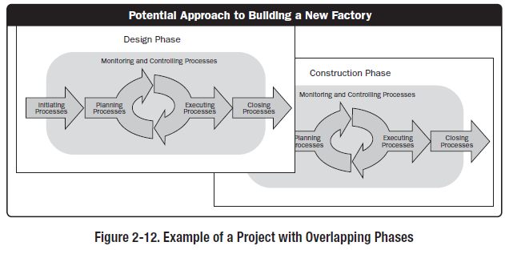
Iterative Relationship
Iterative and incremental life cycles are ones in which project phases (also called iterations) intentionally repeat one or more project activities as the project team’s understanding of the product increases. Iterations develop the product through a series of repeated cycles, while increments successively add to the functionality of the product. These life cycles develop the product both iteratively and incrementally.
Iterative and incremental projects may proceed in phases, and the iterations themselves will be performed in a sequential or overlapping fashion. During an iteration, activities from all Project Management Process Groups will be performed. At the end of each iteration, a deliverable or set of deliverables will be completed. Future iterations may enhance those deliverables or create new ones. Each iteration incrementally builds the deliverables until the exit criteria for the phase are met, allowing the project team to incorporate feedback.
In most iterative life cycles, a high-level vision will be developed for the overall undertaking, but the detailed scope is elaborated one iteration at a time. Often the planning for the next iteration is carried out as work progresses on the current iteration’s scope and deliverables. The work required for a given set of deliverables may vary in duration and effort, and the project team may change between or during iterations. Those deliverables that are not addressed within the scope of the current iteration are typically scoped at a high level only and may be tentatively assigned to a specific future iteration. Changes to the scope of an iteration are carefully managed once work begins.
Iterative and incremental life cycles are generally preferred when an organization needs to manage changing objectives and scope, to reduce the complexity of a project, or when the partial delivery of a product is beneficial and provides value for one or more stakeholder groups without impact to the final deliverable or set of deliverables. Large and complex projects are frequently executed in an iterative fashion to reduce risk by allowing the team to incorporate feedback and lessons learned between iterations.
Conclusion: For projects with more than one phase, there may be different relationships (overlapping, sequential, parallel) between individual phases. Considerations such as level of control required, effectiveness, and degree of uncertainty determine the relationship to be applied between phases. Based on those considerations, both relationships could occur between different phases of a single project.

PROJECT MANAGEMENT PROCESSES
Project management is an integrative endeavor; decisions and actions taken in one knowledge area at a certain time usually affect other knowledge areas. Managing these interactions often requires making trade-offs among the project’s scope, time, and cost—the triple constraint of project management. A project manager may also need to make trade-offs between other knowledge areas, such as between risk and human resources. Consequently, you can view project management as a number of related processes.
A process is a series of actions directed toward a particular result. Project management processes progress from initiating activities to planning activities, executing activities, monitoring and controlling activities, and closing activities.

Initiation Process
The Initiating Process Group consists of those processes performed to define a new project or a new phase of an existing project by obtaining authorization to start the project or phase. Within the Initiating processes, the initial scope is defined and initial financial resources are committed. Internal and external stakeholders who will interact and influence the overall outcome of the project are identified. If not already assigned, the project manager will be selected. This information is captured in the project charter and stakeholder register. When the project charter is approved, the project becomes officially authorized. Although the project management team may help write the project charter, this standard assumes that business case assessment, approval, and funding are handled externally to the project boundaries. A project boundary is defined as the point in time that a project or project phase is authorized to its completion. The key purpose of this Process Group is to align the stakeholders’ expectations with the project’s purpose, give them visibility about the scope and objectives, show how their participation in the project and it associated phases can ensure that their expectations are achieved. These processes help set the vision of the project—what is needed to be accomplished.
Planning processes include devising and maintaining a workable scheme to ensure that the project addresses the organization’s needs. Projects include several plans, such as the scope management plan, schedule management plan, cost management plan, and procurement management plan. These plans define each knowledge area as it relates to the project at that point in time. For example, a project team must develop a plan to define the work needed for the project, to schedule activities related to that work, to estimate costs for performing the work, and to decide what resources to procure to accomplish the work. To account for changing conditions on the project and in the organization, project teams often revise plans during each phase of the project life cycle.
Executing processes include coordinating people and other resources to carry out the various plans and create the products, services, or results of the project or phase. Examples of executing processes include acquiring and developing the project team, directing and leading the project team, performing quality assurance, distributing information, managing stakeholder expectations, conducting procurements, obtaining other project resources, conducting status review meetings, communicating project information and managing project progress.
Monitoring and controlling processes include regularly measuring and monitoring progress to ensure that the project team meets the project objectives. The project manager and staff monitor and measure progress against the plans and take corrective action when necessary. A common monitoring and controlling process is reporting performance, where project stakeholders can identify any necessary changes that may be required to keep the project on track.
Closing processes include formalizing acceptance of the project or project phase and ending it efficiently. Administrative activities are often involved in this process group, such as archiving project files, closing out contracts, documenting lessons learned, and receiving formal acceptance of the delivered work as part of the phase or project.

